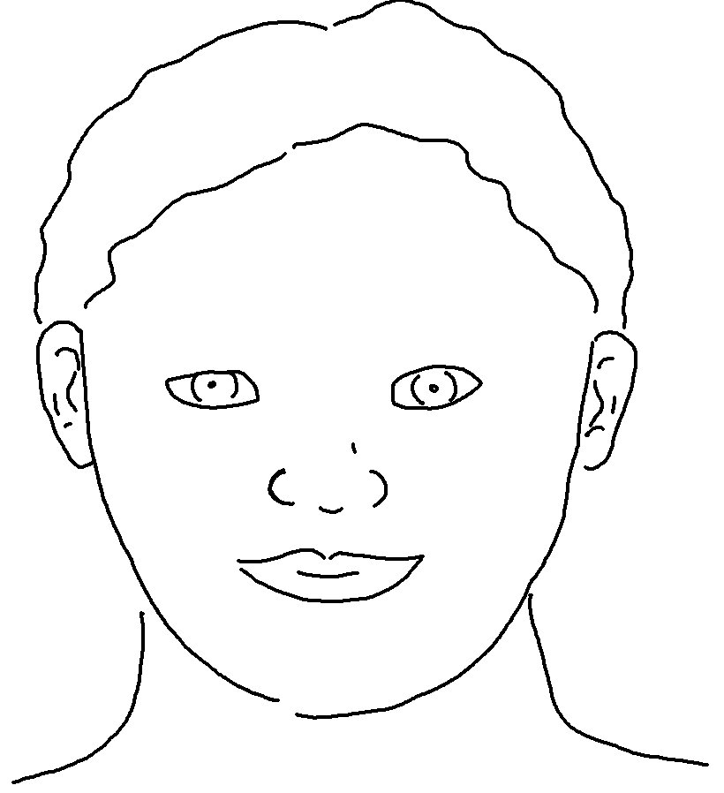
Fix your thoughts on what is _ _ _ _, and honourable, and right,
and _ _ _ _, and lovely, and admirable. Philippians 4:8_{NLT}

